title of the extended abstract

A.A. Surname1*, B.B. Surname2, C.C. Surname3, D.D. Surname1

(1) Affiliation of the 1st author, *e-mail@com.pt of author 1, ORCID author 1

(2) Affiliation of the 2nd author, *e-mail@com.pt of author 2, ORCID author 2

(3) Affiliation of the 3rd author, *e-mail@com.pt of author 3, ORCID author 3

Abstract

This template will assist you in formatting your paper. Please, insert the text keeping the format and styles. The parts of the paper (title, abstract, keywords, sections, text, etc.) are already defined on the style sheet, as illustrated by the portions given in this document. The abstract should include a maximum of 200 words. [Arial, 10-point, justified alignment]

Keywords: Keyword 1, Keyword 2, Keyword 3

# INTRODUCTION [Arial, 12-point, bold, upper case and left alig.]

The final extended abstract length should be between 2 to 4 pages (including references) and can be written in Portuguese or English. All pages size should be A4 (21 x 29,7cm). The top, bottom, right, and left margins should be 2,5 cm. All the text must be in one column and Arial font, including figures and tables, with single-spaced 10-point interline spacing. [Arial, 10 point, normal, justified alignment]

# METHODOLOGY

The extended abstract should contain the description of your study and should be structured in different sections such as: Abstract, Introduction, Methodology, Results, Conclusions, Acknowledgements (if applicable) and References.

# RESULTS

The text included in the sections or subsections must begin one line after the section or subsection title. Do not use hard tabs and limit the use of hard returns to one return at the end of a paragraph.

## Subsection [Arial 12, bold, left alignment and capitalize the first letter]

Please, do not number manually the sections and subsections; the template will do it automatically.

### Sub-subsection: Guidelines for Abbreviations and Acronyms

Define abbreviations and acronyms the first time they are used in the text, even after they have been defined in the abstract. Do not use abbreviations in the title or heads unless they are unavoidable.

### Sub-subsection: Guidelines for Figures and Tables

Tables and figures should be centred and are numbered independently, in the sequence in which you refer to them in the text. Use the abbreviation “Fig. 1”, even at the beginning of a sentence. Figure captions should be below figures and graphics should be accompanied by a legend; table heads should appear above tables.

Table 1. Caption for the table.

|  |  |  |  |
| --- | --- | --- | --- |
|  | Heading 1 | Heading 2 | Heading 3 |
| One | 1 | 2 | 3 |
| Two | 4 | 5 | 6 |
| Three | 7 | 8 | 9 |

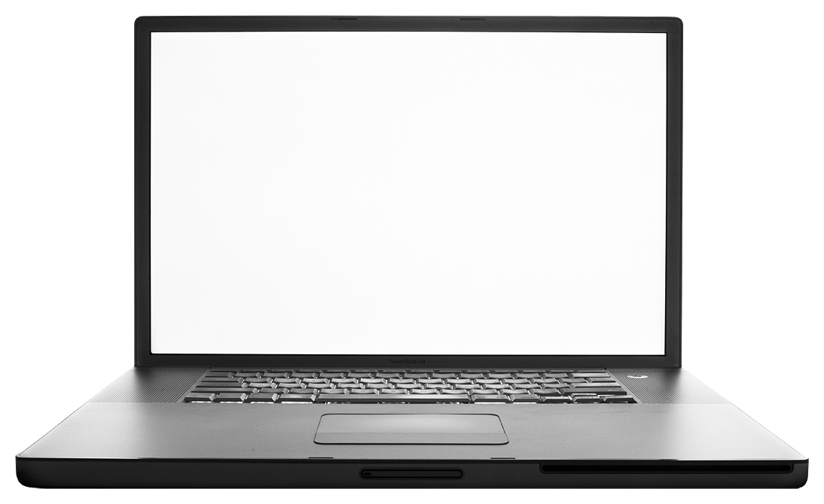

Figure 1. Caption for the figure.

### Sub-subsection: Guidelines for Page numbers and Footnotes

Please, do not add any kind of pagination anywhere in the paper. Avoid using headers and footnotes.

### Sub-subsection: Guidelines for References

The list of the references should be given at the end of the paper. References are numbered in brackets by order of appearance in the document (e.g. [1], [2], [3]). The same reference can be cited more than once in the text with the same reference number. The references should be cited according to the Bibliography and Citation Style: <https://iated.org/citation_guide>.

# CONCLUSIONS

Use as many sections/subsections as you need.

ACKNOWLEDGEMENTS [Arial, 12-point, bold, left alignment]

Optional statement to thank other contributors, assistance, or financial support.

REFERENCES [Arial, 12-point, bold, left alignment]

References [Arial, 10-point, left alignment, upper and lower case] should be cited according to the following style:

A. Einstein, “General theory of relativity,” *Annalen der Physik*, vol. 49, no. 7, pp. 769–822, 1916.

A.A. Author, "Journal/Conference Article Title," *Periodical Title*, vol. Volume, no. Issue, pp.-pp., Publication Year.

A.A. Author, *Book Title*. City/State: Publisher, Year of Publication.

A.A. Author, "Chapter Title" in *Book Title* (Editors eds.), pp.-pp., City/State: Publisher, Year of Publication.

A.A. Author, "Online Article Title," *Periodical* *Title*, vol. Volume, no. Issue, pp.-pp., Publication Year. Retrieved from URL.